**Bikes Testers Test: Write-Up**

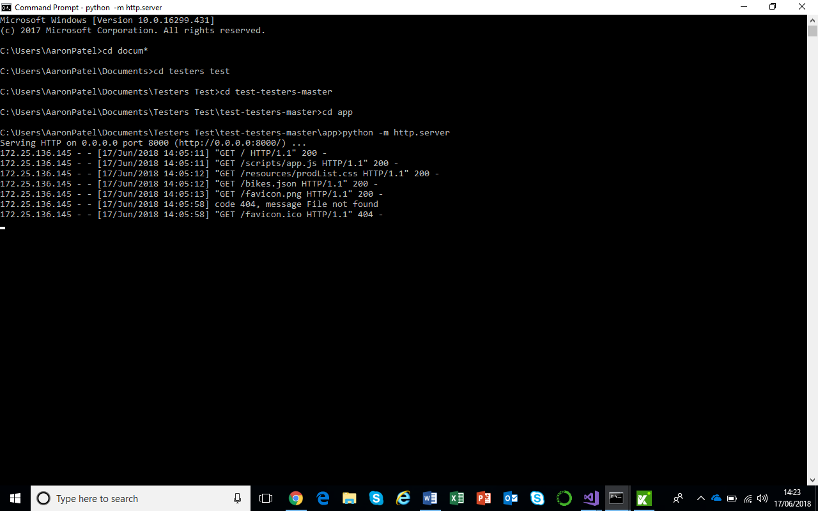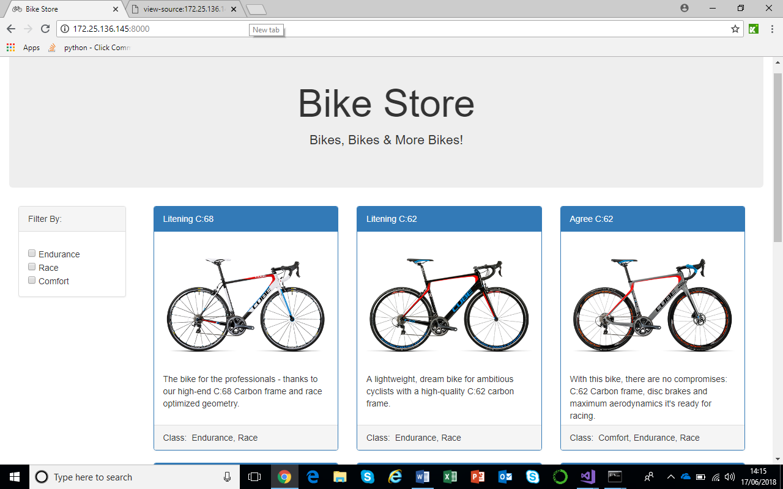The CMD is the start source for the user to run the Application through therefore, select the CMD and run the Python commands as provided through the CMD (Command Prompt), the page is loaded through the local host in which the UI script will be run from. The UI and Integration tests will assure all components are present and working, as requested and required from the User Story. The following scripts will be written using Selenium WebDriver in C#.

The Bike Store page opened using Local Host Port …:8000

**The User Story (1)**

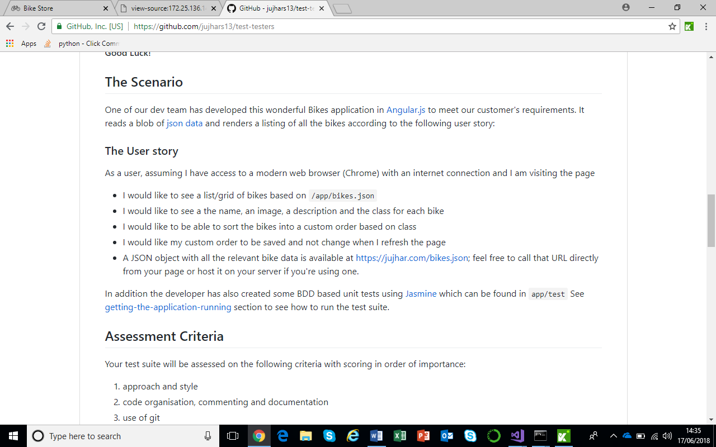

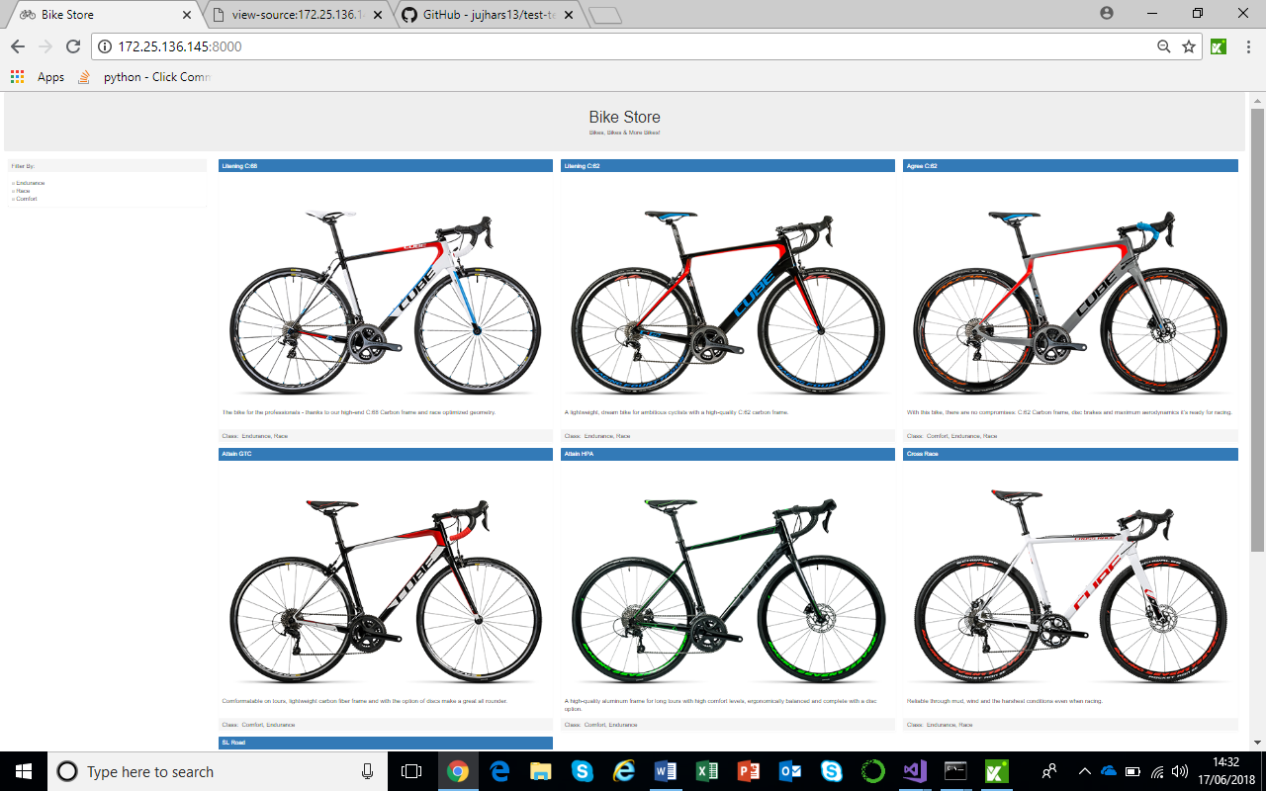

**The User Story (2)**



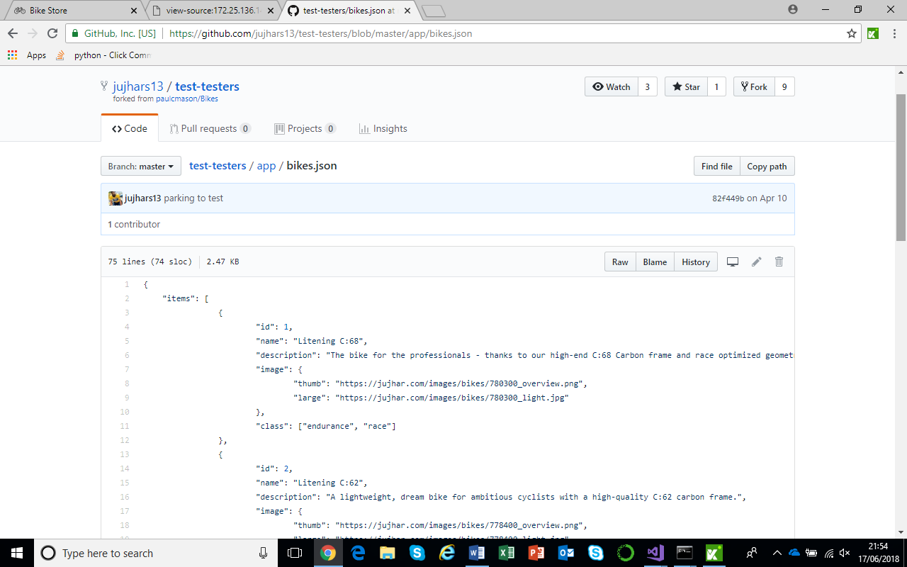

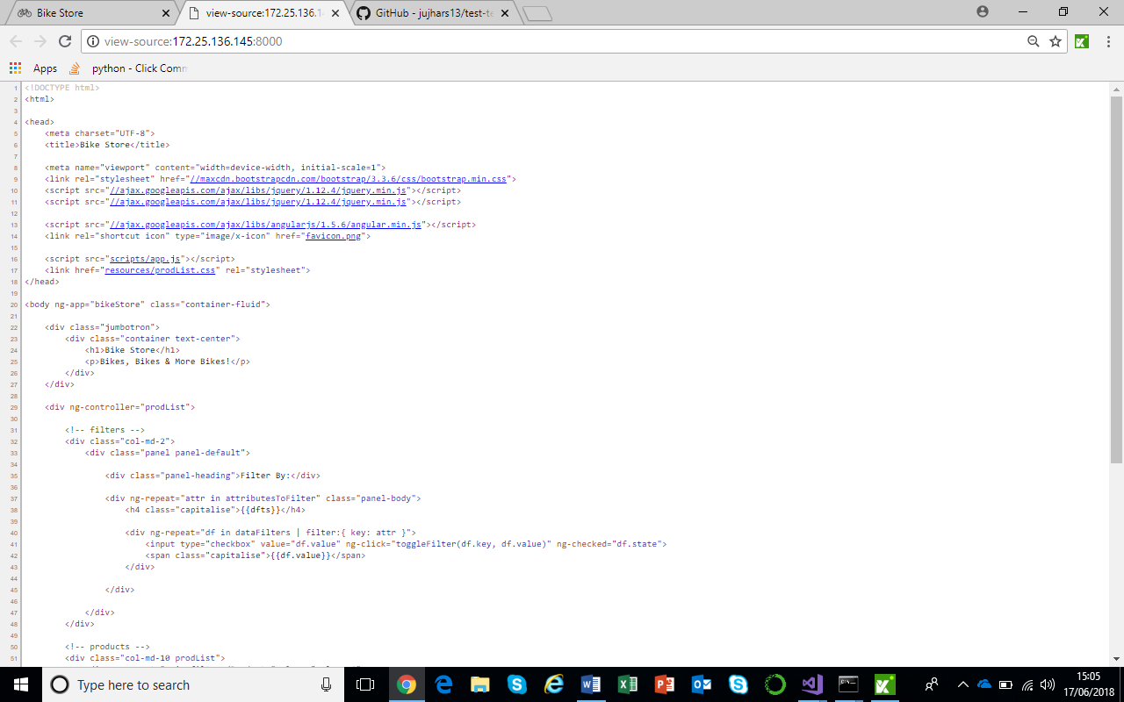The name, image, description and class of bike will be provided within the source code of the webpage. These are provided as shown above. From selecting these elements, the test will assure all attributes are present on the page.

**The User Story (3) & (4)**



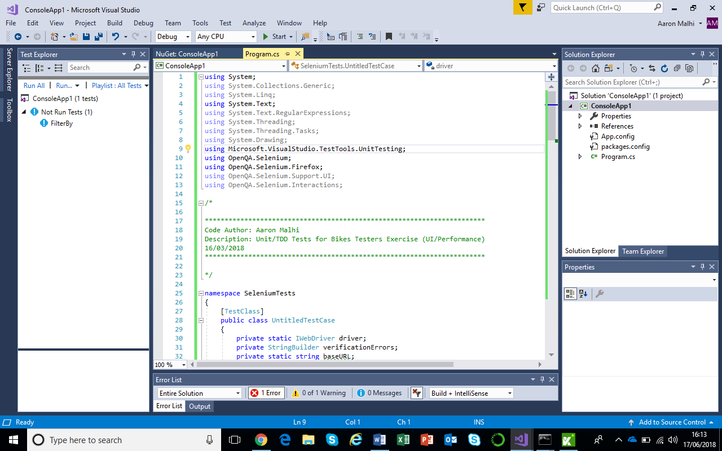

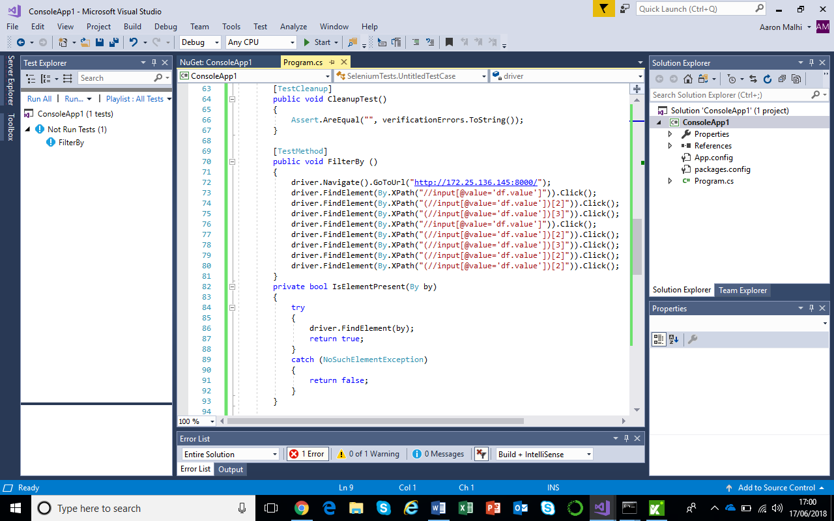

**How to Run (Visual Studio Repository)**

1. Open MS Visual Studio Community
2. Select the repo created
3. Within the Solution Explorer bar, right-click the ConsoleApp1 file name and select ‘Manage NuGet packages’
4. Download the following packages to your machine (MSTest.TestAdapter, MSTest.TestFramework, Selenium.Support, Selenium.WebDriver)
5. Once the following packages have all been installed, select either the ‘Start’ or ‘Run All’ buttons placed on the top or left side taskbar to run the file